Phase II- 31.12.2016

ABSTRACT OF SCIENTIFIC REPORT

The synthesis, characterization and testing as anodes for Li-ion batteries of the Sn-based multicomponent nanocomposites

In this phase we synthesized (using the continuous phase gas/vapor - laser pyrolysis), characterized and tested as anodes for Lithium-ion batteries several tin based naocomposites. The first series consisted of binary type core tin with acarbonaceous shellnanoparticles using Sn(CH₃)₄ and C₂H₄ with/without paraxylene and hydrogen, and the second series consisted of nanocomposites with a complex structure - amorphous matrix containing Si, C and O with a the dispersed phase consisting of nanocrystalline type SnO_{x}. In the synthesis of this second series we used the following precursors: Sn(CH₃)₄, SiCH₃(OCH₃)₃, C₂H₄ and O₂, as well as Fe(CO)₅ in several other experiments where we tried to introduce the iron in these nanocomposites.

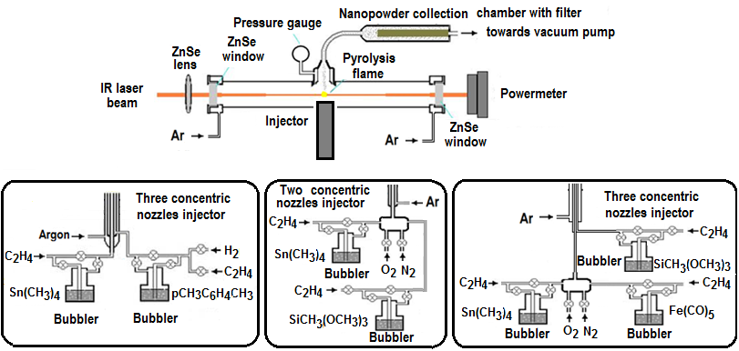
Fig.1 Experimental set-up for the synthesis of Sn-based nanocomposites using laser pyrolysis

Table nr.1 Experimental parameters for the laser pyrolysis synthesis of Sn@C type nanoparticles
Experi-ment | Central flow  D_{C2H4/Sn(CH3)4}  [sccm] | Annular intermediate flow |  |  | Ext.  annular flow | Laser powerbefore/  after ab-sorption  [W] | Flame tempe  rature  [°C] | Pro-duc-tivi-ty  [g/h]
 |  | (D_{C2H4}+D_{H2)}  _{/1,4CH3C6H4CH3}  [sccm] | D_{H2}  [sccm] | D_{C2H4}+D_{Ar}  [sccm] | D_{Arconf}  [sccm]
SPP1* | 5/2.45 | (130 + 0)/3.5 | 0 | 0 | 2500 | 70/66 | 620 | 0.30
SPP2* | 5/2.45 | (100 + 30)/3.5 | 0 | 0 | 2500 | 70/67 | 600 | 0.25
SPP3* | 3/1.47 | (130 + 0)/3.5 | 0 | 0 | 2500 | 70/67 | 580 | 0.14
SPP4# | 5/2.45 | (100 + 30)/3.5 | 0 | 0 | 2500 | 70/66 | 625 | 0.27
SPP5# | 5/2.45 | (30 + 100)/3.5 | 0 | 0 | 2500 | 70/67 | 543 | ?
SPP6# | 5/2.45 | (30 + 100)/3.5 | 0 | 0 | 2500 | 53/50 | 510 | 0.16
SPP7# | 5/2.45 | (30 + 100)/3.5 | 0 | 0 | 2500 | 83/80 | 523 | 0.34
SPP8# | 5/2.45 | 0/3.5 | 100 | 30 + 0 | 2500 | 70/67 | 536 | ?
SPP9# | (2.5+5H₂)/3.67 | 130/3.5 | 0 | 0 | 2500 | 70/67 | 624 | ?
SnC1^{#a} | 12.5/5.25 | 0 | 0 | 21.5 + 21.5 | 2750 | 65/61 | 670 | 1.11
SnC2^{#a} | 12.5/5.25 | 0 | 0 | 21.5 + 21.5 | 2750 | 50/45 | 570 | 0.7
SnC3# | 7/2.94 | 0 | 0 | 50 + 50 | 2750 | 50/45 | 530 | 0.5
Working pressure=450 mbar (45000Pa), with theSnC series exception, where p= 500 mbar (50000Pa);
D_{Arwindows}=2 x 150 sccm;Φ _{int. nozzle}= 0.9 mm; Φ_{intermed.nozzle}= 2.3 mm; Φ_{ext.nozzle}= 14 mm; ª ForSnC1 si SnC2 experiments other injector was used: Φ _{int. nozzle.}= 1.2mm; Φ_{intermed.nozzle}= 2.6 mm; Φ_{ext.nozzle}= 14 mm
*Pulsed laser; # Continuous wave laser; ¤without xylene bubbling

Table nr.2 Experimental parameters for the laser pyrolysis synthesis of SnOSi(Fe) nanocomposites
Experiment | D_{C2H4>}  _{SnMe4}  [sccm] | D_{C2H4>}  _{SiMe(OMe)3}  [sccm] | D_{C2H4>}  _{Fe(CO)5}  [sccm] | D_{N2>}  _{SnMe4}  [sccm] | D_{N2>}  _{SiMe(OMe)3}  [sccm] | D_{N2} | D_{O2} | D_{Ar}  _{confin.}  [sccm] | Pres.  [mbar]
 |  |  |  |  |  | [sccm]
 | Central nozzle |  |  |  |  |  |  | Ext. nozzle
SnOSi1 | 15/8 | 0 | 0 | 0 | 10/1.3 | 0 | 10 | 3500 | 425
SnOSi2 | 0 | 15/1.8 | 0 | 10/4.9 | 0 | 0 | 10 | 3500 | 450
SnOSi3 | 0 | 15/1.8 | 0 | 10/4.9 | 0 | 5 | 10 | 3500 | 450
SnOSi4 | 0 | 15/1.8 | 0 | 5/2.45 | 0 | 5 | 5 | 3500 | 450
SnOSi5 | 0 | 15/1.8 | 0 | 3.33/1.63 | 0 | 6.67 | 10 | 3500 | 450
SnOSi6 | 0 | 15/1.8 | 0 | 5/2.45 | 0 | 5 | 10 | 3500 | 450
 | Central nozzle |  |  | Annular intermediate nozzle |  |  |  | Ext. nozzle
SnOSi7 | 33/19.4 | 0 | 0 | 0 | 5/0.68 | 50 | 25 | 2800 | 400
Sn@SiO1 | 6/2.94 | 0 | 0 | 0 | 33/3.94 | 50 | 25 | 2800 | 450
Sn@SiO2 | 6/3.52 | 0 | 0 | 0 | 33/4.5 | 50 | 25 | 2800 | 400
SnFeSiO1 | 2.67/1.31 | 0 | 5.33/0.52 | 0 | 33/3.94 | 50 | 25 | 2800 | 450
SnFeSiO2 | 1.67/0.82 | 0 | 6.56/0.64 | 0 | 33/3.94 | 50 | 25 | 2800 | 450
SnFeSiO3 | 0.95/0.47 | 0 | 7.62/0.74 | 0 | 33/3.94 | 50 | 25 | 2800 | 450
SnFeSiO4 | 0.8/0.39 | 0 | 8.54/0.83 | 0 | 33/3.94 | 50 | 25 | 2800 | 450
Laser power (under Ar) = 50W;Laser powerafter absorption= 48W;D_{Arwindos}=2 x 300 sccm
Two nozzle injector: Φ_{int. nozzle}= 0.9 mm; Φ_{ext. nozzle.}= 14 mm ; ΦLASER BEAM at 3 mm above the injectori= 1.5 mm
Three nozzle injector:Φ_{int. nozzle.}= 0.9 mm; Φ_{intermed. nozzle.}= 2.3 mm; Φ_{ext. nozzle.}= 14 mm

X-ray diffractograms of powders from SPP series (fig.2) show the presence β-Sn crystalline phase. For SnC powders, only for SnC3 sample one could identify also some weak peaks of SnO phase formed by superficial oxidation due to air exposure (fig.3). SPP1 sample thermogram in air show a mass above 200° due to metallic Sn oxidation to SnO₂ (fig.4)

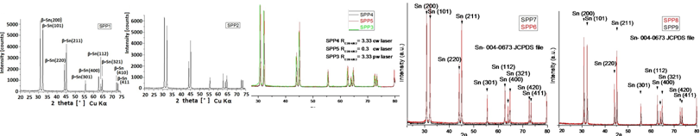
Fig.2 X-ray diffractograms of Sn@C type nanopowders from SPP series

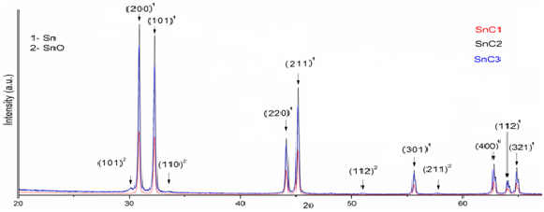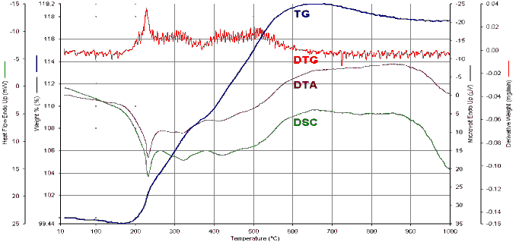
Fig.3 XRD of SnC nanopowders Fig.4 Thermogravimetric curves (in air) of SPP1 sample

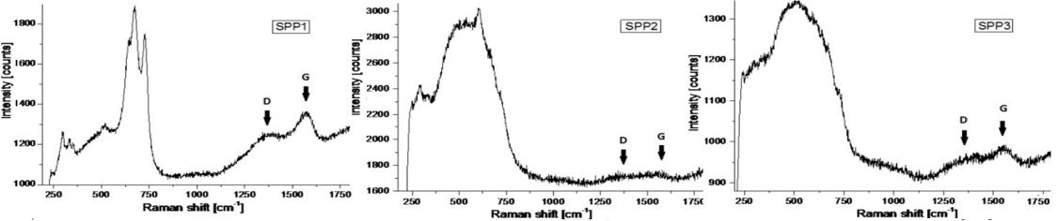
Fig.5 Raman spectra (λ=532 nm) of SPP1, 2 si 3 nanopowders
Raman spectra ale from SPP1,2 and 3 samples (fig.5) show the presence of peaks of SnO₂ (250-800 cm⁻¹region) and also the presence of disorder/turbostratic carbon – D and G large and convoluted bands between 1200-1700 cm⁻¹.

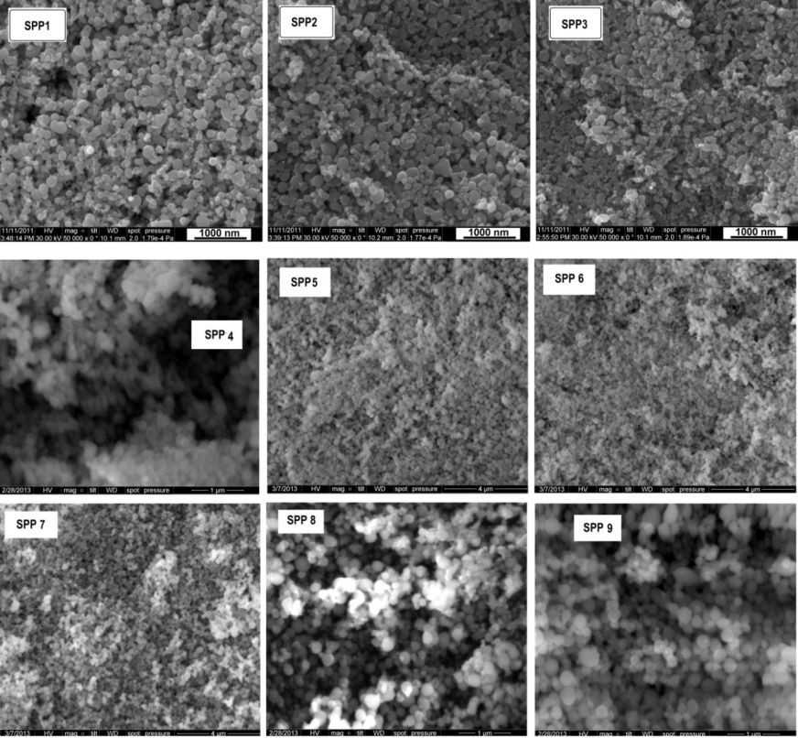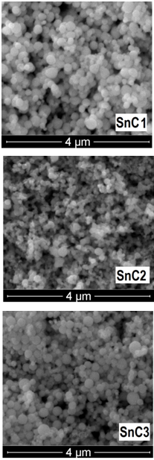
Fig.6 SEM images from SPP1-9 and SnC1-3 nanopowders

SEM images from Sn-C samples (fig.6) show aggregated nanoparticles with rather spherical
morphology, having different dimensions (generally under 200 nm).

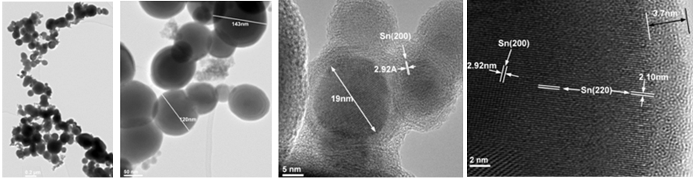
Fig.7 TEM and HR-TEM of the nanoparticles from SPP1 sample

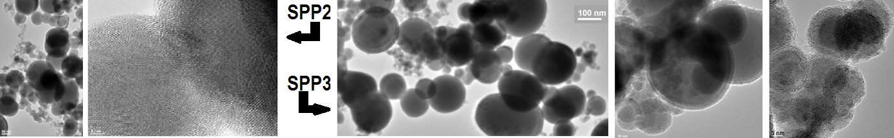
Fig.8 TEM and HR-TEM of the nanoparticles from SPP2 si SPP3 samples

TEM images from Fig.7 and 8 of nanoparticles from SPP1, 2 si 3 samples confirm their spherical morphology and also their very wide size distributon. Also, the presence o a disordered shell and of inner crystalline zones can be observed in HR-TEM images..

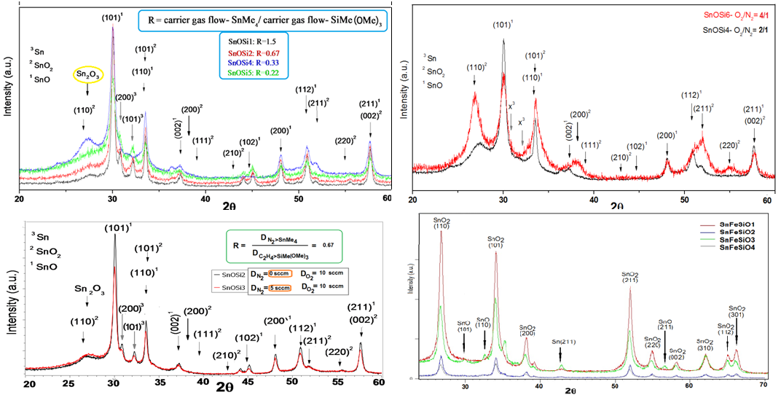
Fig.9 X-ray diffractograms of the SnOSi1+2+3+4, 6+4, 2+3 and SnFeSiO1+2+3+4 samples

For the case of Sn and Si-containing phases, their X-ray diffractograms (fig.9) show only the presence of tin-based crystalline phases: β-Sn, SnO romarchite and/or SnO₂ cassiterite having nanometric dimensions. The introduction of oxygen in in higher quantity during the synthesis favorise the formation of SnO₂. No clear presence of crystalline iron-containing phases was observed when the Fe(CO)₅ precursor was also used in the synthesis of the respective nanoparticles.

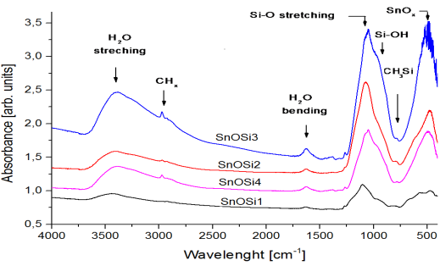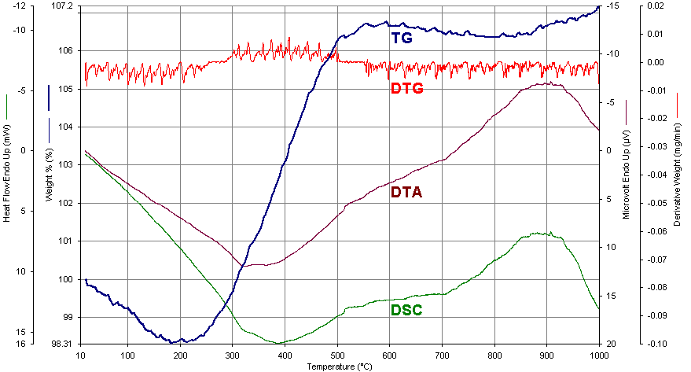
Fig.10 FT-IR spectra of SnOSi1, 2, 3 and 4 powders Fig.11Thermogravimetric curves(in air) of SnOSi5 sample

FT-IR spectra from SnOSi 1-4 samples (fig.10) show the presence of Si-O and Sn-O bonds. Their hydrophylicity is proved by the presence of water molecules specific bands. In the case of the thermogram obtained by SnOSi5 sample air annealing (fig. 12), one can observe a mass gain (lower than in SPP1 case), mainly due to SnO oxidation to SnO₂.

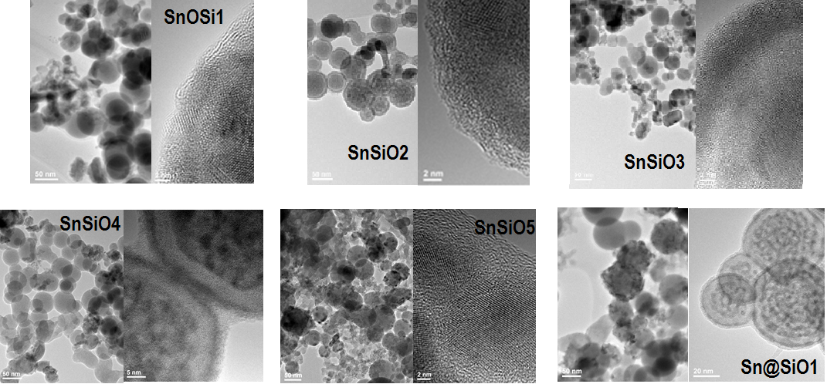
Fig.12 TEM and HR-TEM images of the nanoparticles SnSiO1-5 and Sn@SiO1samples

TEM images from the fig. 12 show the spheroidal nanoparticles (with sizes generally under 70 nm) from the de Sn and Si-containing samples, many of them are inhomogeneous and showing inner substructures with higher contrast. Higher contrast TEM images and also HR-TEM images from the same figure show the existence of small crystalline nanoparticles surrounded by/imersed in a disordered shell/matrix.

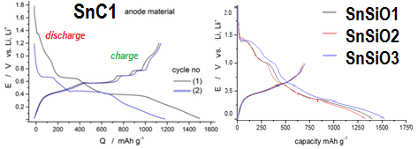
Fig.13 Charge-discharge tests for anodes from SnC1 (left) si SnOSi1, 2 si 3 (right) samples

Charge (lithiation)-discharge (delithiation) tests on anodes prepared using SnC1 or SnOSi1-3 powders show cosiderable capacities at the first cycle, over 1200 mAh/g (fig.13).

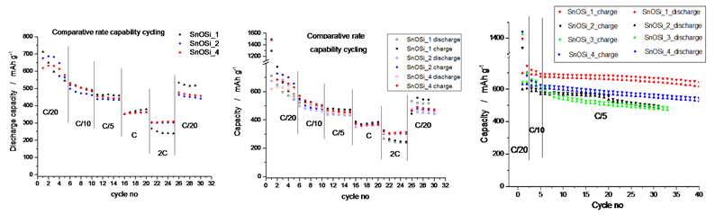
Fig.14 Comparative cycling tests at C/20, C/10, C/5, C, 2C si iar C/2 for SnOSi1, 2 and 4 powder based anodes ; only discharge (left) or both charge and discharge (center) , or at C/20, C/10 followed by multiple cycling at C/5 for anodes based on SnOSi1, 2, 3 si 4 samples (right)

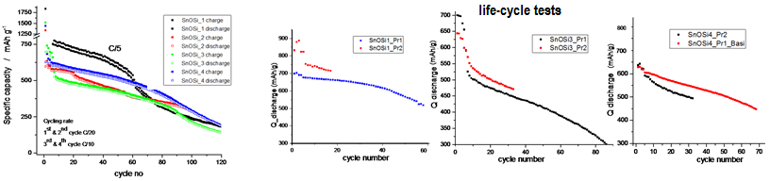
Fig.15 Galvanostatic charge-discharge cycles for anodes from SnOSi 1- 4 samples (left) and cycle-life performances for anodes from SnOSi 1, 3 and 4 samples (right)

The anodes fabricated using SnOSi powders were tested using various charge-discharge rates for many cycles, the best performances being observed for SnOSi1 sample for a number of 35 cycles when they presented capacities between 700 and 650 mAh/g ar C/5 rate.

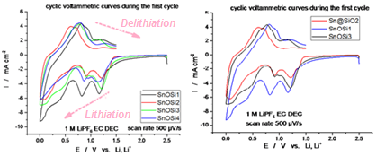
Fig.16 Cyclic voltammograms (only fist cycle) for SnOSi1+2+3 (left) and SnOSi1+3 +Sn@SiO2 (right)

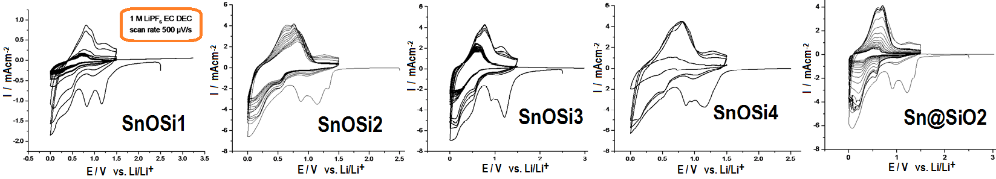
Fig.17 Cyclic voltammograms (multiple cycles) for SnOSi1-5 and Sn@SiO2

Cyclic voltammograms (fig.16 and 17) of the anodes based on nanopowders containing Sn and Si reflect the redox processes which occur during lithiation and delithiation, but also the irreversible formation of Solid electrolyte interface/interphase (SEI) - a process reflected by the catode peak at 0.8 V.

Conclusions
In this phase we synthesized some types of nanoparticles on the basis of tin in the Sn-C system and the type Sn-Si-O-C(Fe) by laser pyrolysis. The nanopowders were analyzed by various techniques, especially XRS, SEM, SEM, Raman, FTIR, TGA, EDS. Some of them have been tested in component anodes for Li-ion batteries proving promising properties for their application in electricity storage.

Dissemination 2016
Works published as scientific articles in journals indexed in International Databases :
- C. Fleaca, F. Dumitrache, E. Dutu, C. Luculescu, A.-M. Niculescu, A. Ilie, E. Vasile ”One step synthesis of tin-carbon core-shell nanoparticles using laser pyrolysis technique” U.P.B. Sci. Bull.B 78 (2016) 43-56
Works reported in the form of posters at conferences or symposia:
- C. Fleaca, F. Dumitrache, C. Vlaic, I. Morjan, A. Bund, M. Stich, I. Sandu, E. Dutu, A. Ilie, A.-M. Niculescu, E. Vasile“Laser pyrolysis synthesized SnO_{x}-SiO₂ nanoparticles for Li-ion battery anodes” E-MRS Spring Meeting, Lille, France, May 2-6, 2016
- F. Dumitrache, C. Fleaca, E. Dutu, C. Vlaic, A. Ilie, A.-M. Niculescu, M. Scarisoreanu, E. Barna, I. Morjan, E. Vasile, A. Bund, M. Stich “Cobalt doped and undoped mixed tin oxides nanopowders synthesised by laser pyrolysis”E -MRS Spring Meeting, Lille, France, May 2-6, 2016
- F. Dumitrache, A. Rotaru, C. Fleaca, I. Morjan, E. Dutu, A.-M. Niculescu, A. Ilie, E. Vasile“Structural and thermal study of Sn-based nanocomposite powders obtained by one-step laser pyrolysis”, 25th Symposium of Thermal Analysis and Calorimetry "Eugen Segal", Bucharest, Romania, April 15, 2016

